9/18 Containerization with Docker

1. Docker: a set of platform as a service (PaaS) products that use OS-level virtualization to deliver software in packages called containers
   * Make sure your applications work seamlessly in any environment which can be development or test or production
   * Written in Go language
   * Portable for any system running the Linux Operating system (OS) or Windows OS
   * Easily scale up and down the number of systems
   * Comes into play at the deployment stage of software development cycle

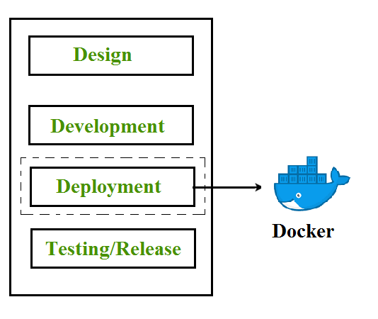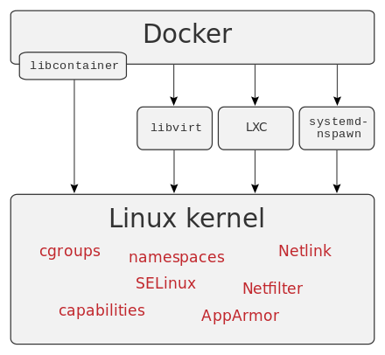

Operation Chart (cited from Wikipedia) Chart cited from geeksforgeeks

1. Containerization
   * OS-based virtualization which creates multiple virtual units in the userspace, known as Containers
   * Containers share the same kernel but are isolated from each other through private namespaces and resource control mechanisms at the OS level
   * Comparison with **Hypervisors**:
     1. Hypervisors use lot of hardware (more overhead) in terms of virtualizing hardware and virtual device drivers
     2. Containers implement isolation of processes at the operating system level, thus avoiding such overhead
   * Containerization has better resource utilization compared to VMs and short boot-up process
2. Docker Architecture
   * Consists of Docker client, Docker Daemon running on Docker Host and Docker Hub repository
   * **Docker client and servers** – consists of all containers; receives the request from the Docker client through CLI or REST API’s
   * **Docker Images** – lightweight, standalone, executable package of software that is used to build docker containers by using a read-only template
   * **Docker File** – Dockfile is a text file that contains a series of instructions on how to build your Docker image
   * **Docker Registries** – Docker Registry is a storage component for Docker images
   * 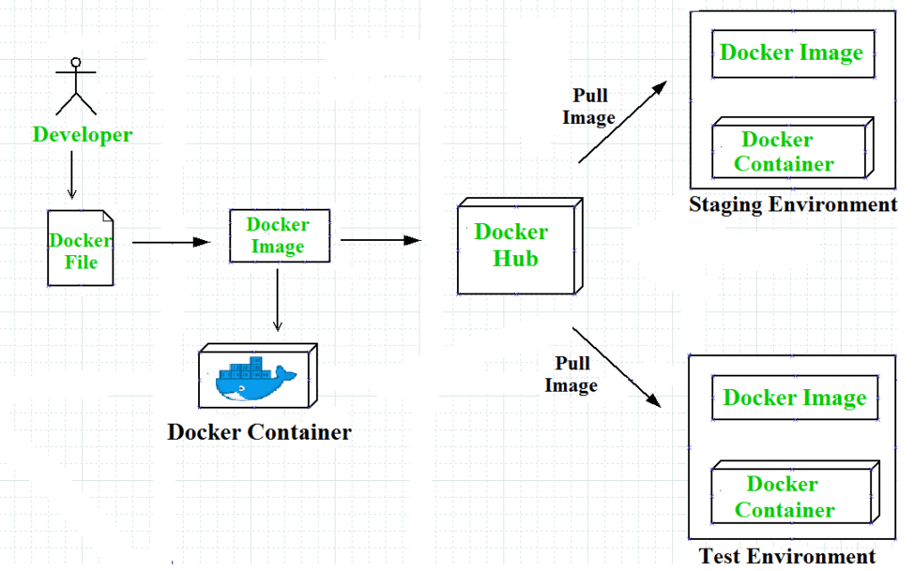**Docker Containers** – Docker Containers are runtime instance of Docker image. Containers contain the whole kit required for an application, so the application can be run in an isolated way
3. Three Docker Networks Types
   * Bridged network
   * Host network
   * None network
4. Advantages of Docker
   * Speed
   * Portability
   * Scalability
   * Density

Source Cited:

<https://www.geeksforgeeks.org/containerization-using-docker/>